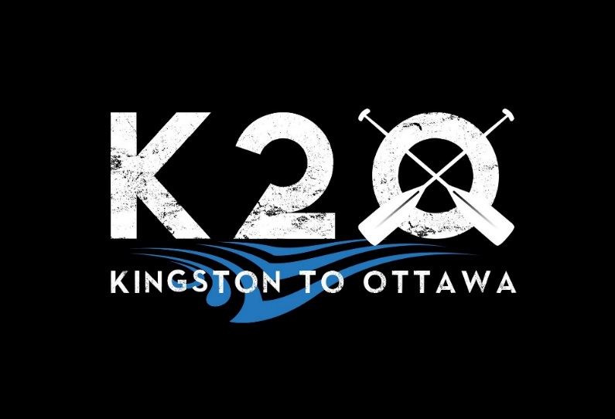

2024 Official Race Rules

August 10th, 2024

Version 2024-02

Introduction
The Kingston to Ottawa (K2O) Race Rules and Regulations are put in place for the fairness and safety of all participants, including racers, support crews, and staff. Abiding by these rules ensures that the event is run efficiently and safely.
The 2024 race is available in a 90km and 40km format. The 200km is not available for this year’s race, but is planned for future years.

Summary of Changes for 2024 that differ from past years

Route
The route starts at Rideau Ferry and travels south to Kingston.

Support
Portage support is allowed for both Adventure and Competitive classes. See section 5.5.

PFDs
PFDs may be required to be worn by all racers while on the water. See section 4.

Canoe Classes
See section 3 for new criteria for canoe classes.

Registration

How to Register
Registration must be completed using the online registration form available at http://www.kingston2ottawa.ca.

Eligibility
All paddlers must be at least 18 years of age at the start of the race to be eligible to participate. Waiver forms are required at race kit pickup.
Entry fees are determined by race class and registration date. Participants are encouraged to register early to avoid paying higher fees. The fee schedule is provided below.
Note: The 2024 race will not levy a fee for tracking devices.
A tracking app will be required to be installed on all racers Smartphones.

Safety Note: The Kingston 2 Ottawa is a marathon paddling event, during which the entirety of the route cannot be monitored. It is expected that all racers are able to self-rescue, and get to shore in the event of bad weather, capsizing, or other unexpected events. Race staff have 8 checkpoints along the route to monitor racer progress. Support crews for racers are highly recommended to assist racers in the event of unexpected withdrawal. Transportation is not provided along the route.

K2O Half Distance (Start at Rideau Ferry)
Number of racers in team | Until May 15th | Until July 15th | Until August 6th
1 paddler | $125 | $150 | $200
2 paddlers | $175 | $200 | $250
3 or more paddlers | $75 + $50/paddler | $100 + $50/paddler | $150 + $50/paddler

K2O Quarter Distance (Start at Seeley’s Bay)
Number of racers in team | Until May 15th | Until July 15th | Until August 6th
1 paddler | $75 | $100 | $150
2 paddlers | $125 | $150 | $200
3 or more paddlers | $25 + $50/paddler | $50 + $50/paddler | $100 + $50/paddler

Entry Deadlines
The deadline for entry is August 4th at 8pm. Entries will not be accepted after this time.

Change of Class
Paddlers who wish to change class can do so by contacting race organizers. An administration fee of $20 will apply to each paddler involved.

Cancellations / Widthdrawals before the race
Teams withdrawing from the race will have a portion of their entry fee refunded:
- Until June 15th: 100% refund
- Until July 21st: 75% refund
- After July 21st: no refund

Classes and Categories
The race classes for the K2O are defined in the grid below. Boat specifications are defined by the Ontario Marathon Canoe Kayak Racing Association (OMCKRA), and are listed on their website,
https://www.omckra.com/education.
Guidance on kayak class can be determined at https://www.soundrowers.org/boat-classes/

Racers who are uncertain of their class should contact race organizers for clarification.
Adventure Eligibility | Competitive Eligibility
C1: Max length 17’, Min width* 32”  C2: Max length 17’, Min width* 32”  K1: Long Recreational & Short Recreational Kayaks  K2: Recreational  SUP: All  North / Voyageur Canoes: All  Unlimited: All | C1: Stock C1, USCA C1 and ICF C1  C2: Stock C2, Pro C2 and ICF C2  K1: Fast Kayaks (FK), High Performance Kayaks (HPK) & Recreational Kayaks  K2: All  SUP: All  North / Voyageur Canoes: All  Unlimited: All
- * width is hull width measured 4" above waterline.

Each class will be further divided into category by gender – men’s, women’s, and mixed. Mixed teams must be composed of at least one third women.
All crafts must be powered solely by human power using non-fixed paddles. These include, but are not limited to, canoes, kayaks, voyageurs, SUPs, surf skis, voyageurs (north canoes), and outriggers. Examples of excluded crafts are row boats, sail boats, and pedal boats. Crafts may not be substituted during the race.
Crafts with non-fixed blades which do not fit the specifications, such as outriggers, ruddered canoes, modified kayaks, may register as ‘Unlimited’.
Race organizers may, at their discretion, measure crafts to ensure they are within specifications.

Mandatory Equipment
The following is the list of mandatory gear for the race. They are based on the minimum Transport Canada requirements. We frequently receive questions on mandatory gear: we hope these clarify the requirements, but feel free to drop us a line if you’re not certain!

1) One PFD per paddler (see notes below)
2) One sound signaling device
3) One buoyant heaving line, at least 15m long
4) Bailer which can hold 750ml of liquid or bilge pump. Exception to this rule are boats which cannot hold enough water to make it capsize or a boat that has watertight compartments that are sealed and not readily accessible. Generally, this means canoes and kayaks will require a bailer, while SUPs, OCs, and surfskis will not. Canoes with venturi self-bailers are not exempt from the bailer requirement.
5) Watertight flashlight for each racer. This can be hand-held or head mounted. Note that headlamp style lights have a couple significant disadvantages: they can produce a ‘strobe’ effect while paddling, and are not as useful for finding the red/green buoys in the dark if you leave the navigation channel. A strong handheld flashlight and/or boat-mounted headlamp is strongly recommended. Lights are only required when paddling after sunset: they do not need to be in your boat until they are required.
6) Navigation light. As per Transport Canada requirements, this can be the same light as your flashlight. Red/green motorboat navigation lights are not required. Lights are only required when paddling within thirty (30) minutes of sunset: they do not need to be in your boat until they are required.
7) Maps covering the racecourse. These can be printed Google maps. They must have sufficient detail to help you find your way if you are lost. GPS devices with map capability are sufficient.
8) Boat number stickers: Stickers will be in racer kits and are to be affixed to your boat, if possible. If not possible (on a SUP for example), attempt to find a conspicuous location on your gear. You may be asked for your boat number by volunteers during the race.
9) Working cell phone in a waterproof container. A waterproof bag or phone case are ok.
10) Some teams will be asked to carry a tracking device during the race. These may be assigned during the race.
Notes:
New rule for 2024: It may be mandatory that PFDs be worn while on water by all racers. This will be determined on race day based on weather. Noncompliance will result in disqualification.
Inflatable PFDs are acceptable if they meet Transport Canada requirements. In addition to being certified, they 1) must be worn at all times when on water, and 2) have an undamaged inflation cartridge that is in good working condition.

Race Procedures

Pre-Race Briefing
A pre-race briefing must be attended by all participants. The briefings will take place approximately 30 minutes before each race start at the start location. This meeting will provide participants with last minute updates and race instructions.

Race Starts
All race distances begin with a mass start at the following locations and times:

- Half K2O (90km): 6:00AM EST Saturday August 10th, 2024 at Rideau Ferry (CC’s on the Rideau).

- Quarter K2O (40km): 12:00 noon EST on August 10th, 2024 near Seeley’s Bay. Exact location TBD.
.

Late starts are accepted up to 15 minutes after the scheduled start; however, race times are calculated from the scheduled race start time, not the paddle start time.

Cut off times
The following cut-off times must be met by all racers. Teams which do not meet cut-off times, will be required to resign from the race. Race organizers may, at their discretion, adjust cut-off times depending on race day conditions.

- Jones Falls: 2:00pm
- Upper Brewers: 5:15 pm
- Cataraqui Canoe Club (Finish): 10:00 pm

Please track your speed on training paddles with portages to ensure you can meet the cut-off times. Volunteers have signed on for specific shifts, and paddlers cannot be on the course without monitoring.

Portaging
Racers must portage around all lock stations using the prescribed portage routes. At these lock stations, racers must provide their team number to the attending officials.
Lock station facilities are shared with other user groups, such as pleasure boaters. Racers must be aware of possible boat wash and significant activity around lock stations, particularly during the day.
Racers must obey the instructions from the volunteer safety guides posted at major road crossings. As deemed necessary, safety guides may require you to wait before crossing the road. Penalties will be assigned to teams who do not follow safety guide instructions.

Support
The Kingston 2 Ottawa is a supported paddling marathon. Racers can have a support team to provide food, drinks, medicine, clothing, ice, or other items which they require. Support teams can provide support from all lock stations and sites that are accessible to the public.
Non-registered boats, including motorboats, cannot not follow, lead, or be used to provide assistance to any racer throughout the race.
New: Portaging Support for all classes, Adventure and Competitive - Support crews can provide portaging assistance to racers. This includes lifting the craft out of the water, portaging it around the lock station, and putting the craft back in the water. Portaging devices (e.g. portaging trailers) are allowed to be used by all racers and their support crews.

Resignation
A team may resign from the race at any time by contacting race officials and completing a resignation form. Race officials must be informed at the earliest possible time.

Prizes and Awards

Medals
Team members of the top teams in their respective class, category, and division will be given medals.

Top finisher
Fastest finishing team in each distance will earn a free registration for the following year’s race in the distance of their choice. In determining the registration awards, distinctions will not be made between class or category.

General

Code of Conduct
All participants are expected to adhere to sportsmanlike conduct. The Rideau Canal waterway is used by many interest groups and, as such, impact to other groups must be minimized. Land along the canal must be respected. Trespassing on private property is both prohibited and not required. Part of the race may take place during the night; paddlers and their support crews are asked to be respectful and keep noise levels low. The use of drugs and alcohol is strictly prohibited.

Rule Violations
Inappropriate behavior by supporters and/or competitors will be penalized at the discretion of race officials.

Protests
Protests must be addressed in writing to the race organizers within two hours of completing the race. The protest must clearly indicate which rule was violated, and details of the complaint. A fee of $30 will be levied, which will be returned if the protest is upheld.

Document Revisions
Revision Number | Revision Date | Description of Changes
Version 2024.01 | Jan 23, 2024 | - Changes 2024.

